Class: CMSC203 CRN 36406

 Program: Assignment #2

Instructor: Professor Eivazi

 Summary of Description: Build an application that will receive a guess and report if your guess is the random number that was generated. Your application will narrow down the choices according to your previous guesses and continue to prompt you to enter a guess until you guess correctly.

Due Date: 02/023/2022

 Integrity Pledge: I pledge that I have completed the programming assignment independently.

 I have not copied the code from a student or any source.

**Part1: UML Diagram:** Here is a UML Diagram for Assignment 2 program:

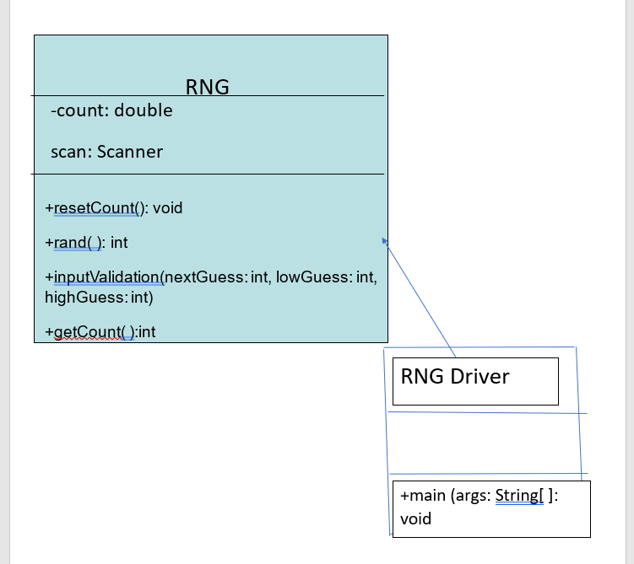

**Part2: Comprehensive Test Plan**

A good test plan should be comprehensive. This means you should have a few test cases that test when the input is in and out of range, division by 0, incorrect Data type, etc (Provide valid and invalid input)

|  |  |  |  |  |
| --- | --- | --- | --- | --- |
| Cases | Input | Expected Output | Actual Output | Did Test Pass? |
| Case 1 | Enter your first Guess: 99.  Guesses:1  Your guess is too high  Enter next guess bw 0 and 99  Next Guess: 66  Guesses: 2  Your guess is too low.  Next guess between 66 and 99  Next Guess: 73  Guesses: 3  Congratulations, you guessed correctly.  Try again: no  Thanks for playing. | 99  Guesses: 1  Your guess is too high  66  Guesses: 2  Your guess is too low  73  Guesses: 3  Congratulations, you guessed correctly.  No  Thanks for playing …... | 99  Guesses: 1  Your guess is too high  66  Guesses: 2  Your guess is too low  73  Guesses: 3  Congratulations, you guessed correctly.  No  Thanks for playing | YES |
| Case 2 | First Guess: 2  Your guess is too low.  Second Guess: 77  Your guess is too high.  Third Guess: 80  Try again (must be bw 2 and 77)  44  Your guess is too high  Fourth Guess: 4  Congratulations, you guessed correctly.  Try again=n  Thanks for playing | 2  Guesses: 1  Your guess is too low  77  Guesses: 2  80  44  Guesses: 3  Your guess is too high  6  Guesses: 4  Congratulations, you guessed correctly.  No  Thanks for playing.... | 2  Guesses: 1  Your guess is too low  77  Guesses: 2  80  44  Guesses: 3  Your guess is too high  6  Guesses: 4  Congratulations, you guessed correctly.  No  Thanks for playing | YES |
| Case 3 | First Guess: 77  Your guess is too low.  Second Guess: 99  Congratulations, you guessed correctly.  Try again: yes  First Guess: 11  Your guess is too low.  Second Guess: 33  Your guess is too high.  Third Guess: 22  Congratulations, you guessed correctly.  Try again=n  Thanks for playing | 77  Guesses: 1  Your guess is too low.  99  Guesses: 2  Congratulations, you guessed correctly  Try again: no  Thanks for playing.... | 77  Guesses: 1  Your guess is too low.  99  Guesses: 2  Congratulations, you guessed correctly  Try again: no  Thanks for playing.... | YES |
| Case 4 | First Guess: 78  Your guess is too low.  Second Guess: 99  Congratulations, you guessed correctly.  Try again: no | 78  Guesses: 1  Your guess is too low.  99  Guesses: 2  Congratulations, you guessed correctly.  Try again: no  Thanks for playing.... | 78  Guesses: 1  Your guess is too low.  99  Guesses: 2  Congratulations, you guessed correctly.  Try again: no  Thanks for playing.... | YES |

**Part3: Screenshots related to the Test Plan:**

GITHUB: Java File uploaded to GitHub.

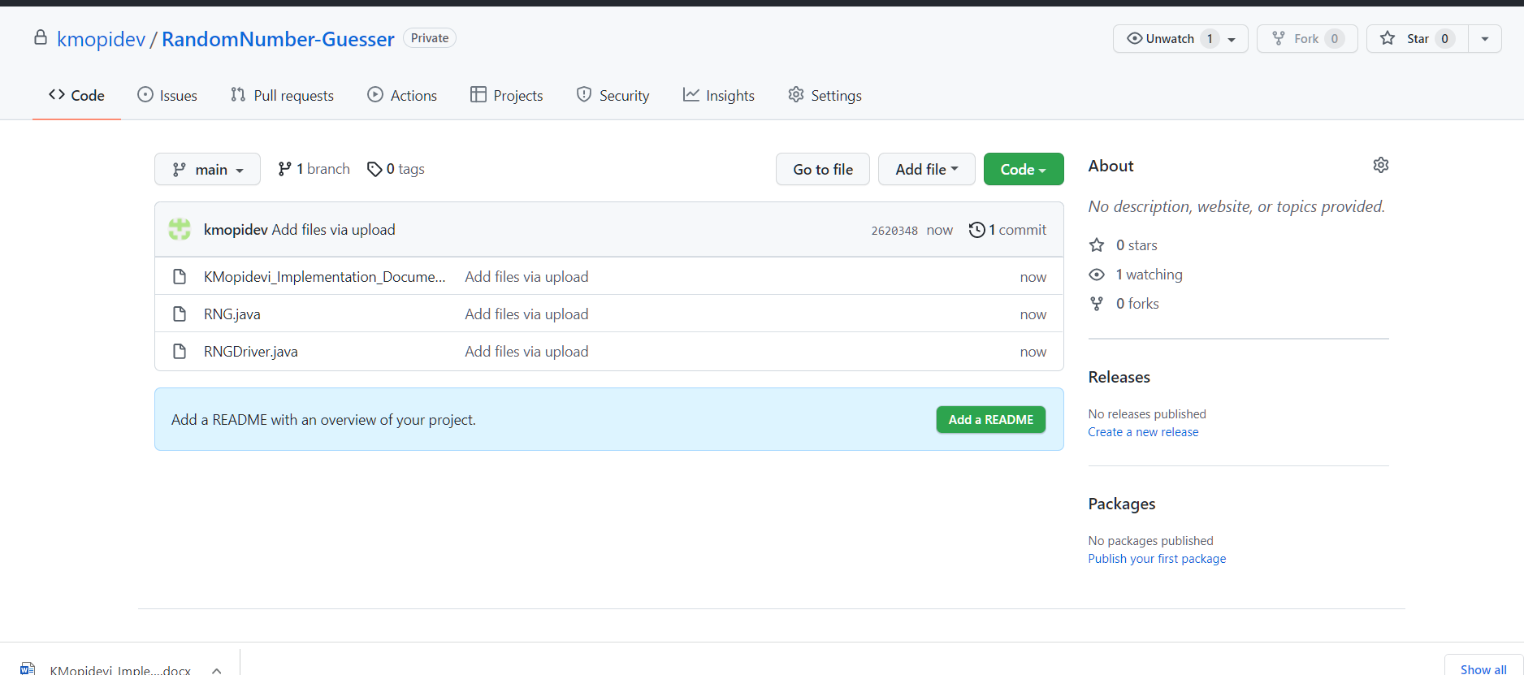

**Lessons Learned** <Provide answers to the questions listed below>**:**

Write about your Learning Experience, highlighting your lessons learned and learning experience from working on this project.

=>What have you learned?

I learned to create a driver class, objects, using do while loop and if/ else statements. In this assignment I had to use nested do while loop which I did not do in the previous class CMSC 140 so that was new to me, and I learned it. I was a little bit confused about how to create an object in the driver class from the main class, but this assignment helped me understand how to create objects in the driver class from using the main class.

=>What did you struggle with?

This assignment was challenging for me. The examples in the class were easy but this program was challenging because it was a guessing game and I had to use a do while loop inside a do while loop which really confused me. I used to do while loop to ask the user if they wanted to try again then while I compiled it, it was running like an infinite loop it was not stopping after entering the first guess number. So, fixing that problem was a bit challenging for me. I went to the tutoring center to get help of how to run the java program through the command line. Now I understand the steps and feel more confident in running the java program through the command line.

=>What would you do differently on your next project?

I would start the project much earlier than the due date and complete the implementation document also. Though I wrote the code earlier it is taking me more time to complete the implementation document where I am feeling more stressed. Hence, I will try to do the above steps for the next project, so I do not feel anxious and have more time to check back to see if I completed everything on the checklist and have time to make any changes if needed.

=>What parts of this assignment were you successful with, and what parts (if any) were you not successful with?

I was successful in creating a java project in eclipse, creating a class, importing the RNG.java and creating RNGDriver. Then, I was successful in asking the user to enter their guess, updating the number of guesses played, and asked the user if they wanted to play the game again. But the part I was not successful in was when compiling the project, it runned like an infinite loop it was not stopping it was just running after the user enter their first guess number.

=>Provide any additional resources/links/videos you used to while working on this assignment/project.

I did not use any additional videos, I just read chapter 4 for help in the loops. And chapter 6 helping me in creating the driver class. I also reviewed the PowerPoints and the driver classes practiced in class. I went to the coach session to make the concept clear of how to stop my program from running like an infinite loop. Also, I went to the virtual tutoring center to learn how to run the java program through the command line.

**Check List:** <Provide answers to the column Y/N or N/A >**:**

|  |  |  |  |
| --- | --- | --- | --- |
| **#** |  | **Y/N** | **Comments** |
|  | **Assignment files:** |  |  |
|  | * FirstInitialLastName_ Assignment#_Moss.zip | **Yes or No** | **YEs** |
|  | * FirstInitialLastName_Assignment#.docx/.pdf | **Yes or No** | **YES** |
|  | * Source java files | **Yes or No** | **YES** |
|  | **Program compiles** | **Yes or No** | **YES** |
|  | **Program runs with desired outputs related to a Test Plan** | **Yes or No** | **YES** |
|  | **Documentation file:** |  |  |
|  | * Comprehensive Test Plan | **Yes or No** | **YES** |
|  | * Screenshots related to the Test Plan | **Yes or No** | **YES** |
|  | * Screenshots of your GitHub account with submitted Assignment# (if required) | **Yes or No or N/A** | **YES** |
|  | * UML Diagram (if required) | **Yes or No or N/A** | **YES** |
|  | * Algorithms/Pseudocode (if required) | **Yes or No or N/A** | **N/A** |
|  | * Flowchart (if required) | **Yes or No or N/A** | **N/A** |
|  | * Lessons Learned | **Yes or No** | YES |
|  | * Checklist is completed and included in the Documentation | **Yes or No** | YES |